Array Methods

Array.fill()

The **fill()** method changes all elements in an array to a static value, from a start index (default 0) to an end index (default **array.length**). It returns the modified array.

Array.find()

The **find()** method returns the first element in the provided array that satisfies the provided testing function. If no values satisfy the testing function, [**undefined**](https://devdocs.io/javascript/global_objects/undefined) is returned.

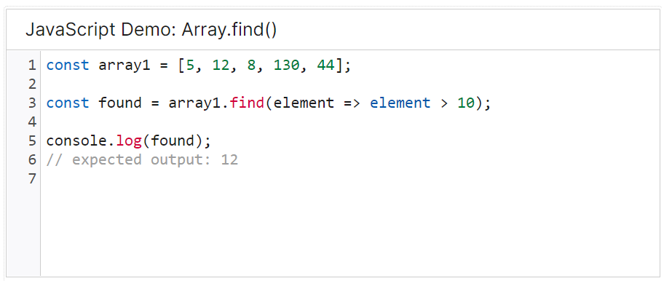

**Array.pop()**

The **pop()**method removes the **last** element from an array and returns that element. This method changes the length of the array.

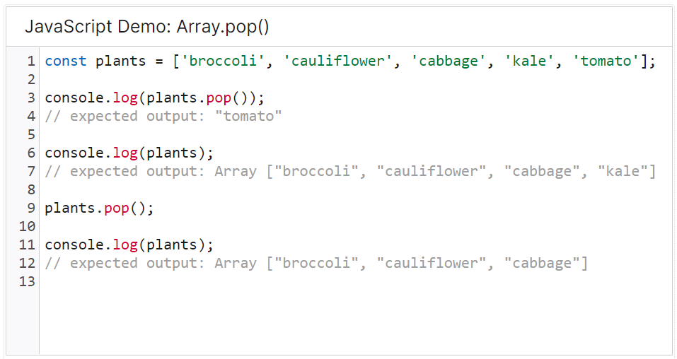

**Array.map()**

The **map()** method **creates a new array** populated with the results of calling a provided function on every element in the calling array.

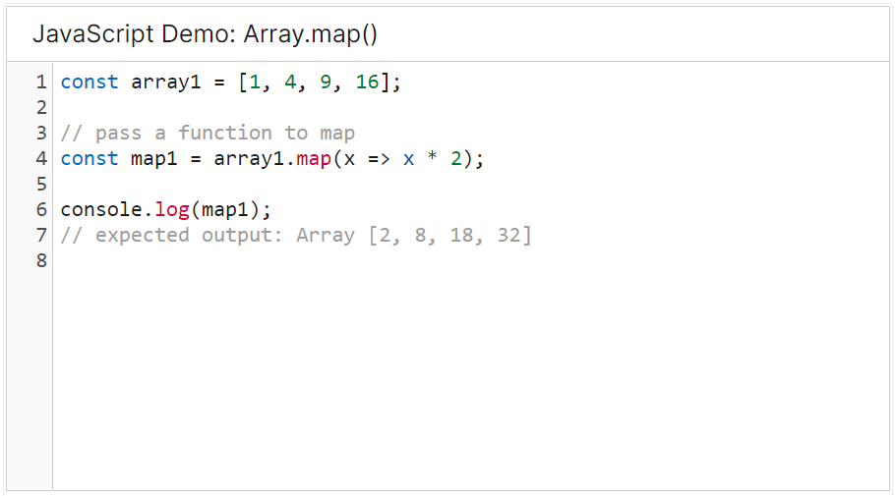

**Array.push()**

The **push()** method adds one or more elements to the end of an array and returns the new length of the array.

**Array.shift()**

The **shift()**method removes the **first** element from an array and returns that removed element. This method changes the length of the array.

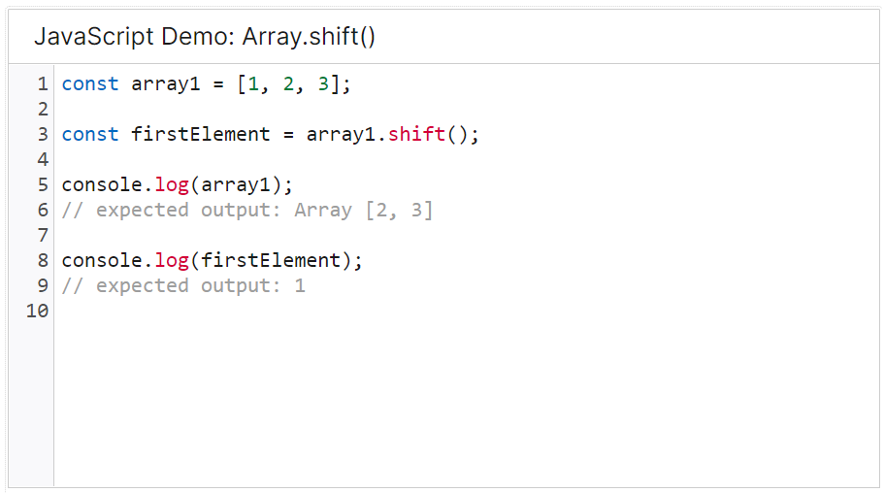

**Array.unshift()**

The **unshift()** method adds one or more elements to the beginning of an array and returns the new length of the array.

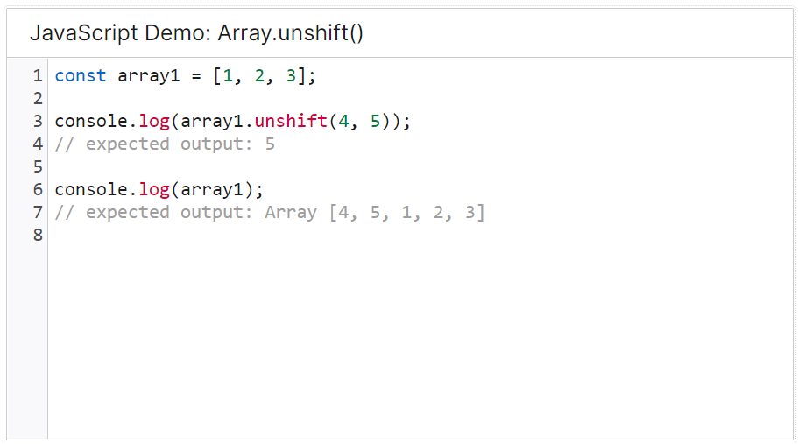

**Array.includes()**

The **includes()** method determines whether an array includes a certain value among its entries, returning true or false as appropriate.

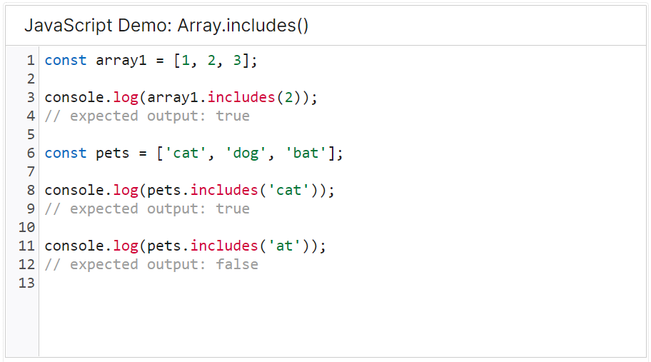

**Array.splice()**

The **splice()** method changes the contents of an array by removing or replacing existing elements and/or adding new elements [in place](https://en.wikipedia.org/wiki/In-place_algorithm).

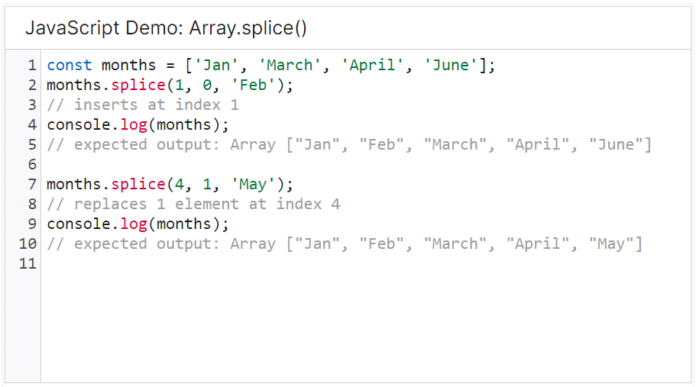

**Array.slice()**

The **slice()** method returns a [shallow copy](https://developer.mozilla.org/en-US/docs/Glossary/Shallow_copy) of a portion of an array into a new array object selected from start to end (end not included) where start and end represent the index of items in that array.

